Practice this only in Service-Now Demo instance

Assignment:

1. Create one catalog item ‘Request for new software’ under Category ‘Services’

Form Name: Request for new software
Category: Services

Please include the following sentences at the beginning of the form:

‘Use this form to request a new software installation.’

1. Requestor (auto populate with current user):

Requestor is a reference field, referencing to user table.
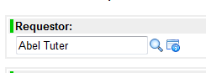

2. Manager (Should auto populate):

Manager is a reference field, referencing to user table

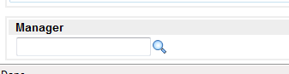

3. Behalf of (Mandatory):

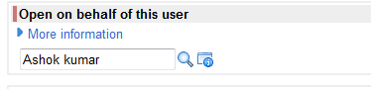

This search should be only on users whose company is same as the company of Requestor (Add Reference qualifier)”.

4. Location (Mandatory):

Location is Drop down field

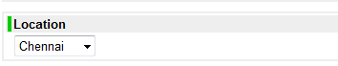

Locations that need to be available in the drop down are detailed below:

- Chennai
- Bangalore
- Mumbai

5) Building

Building is a drop down field

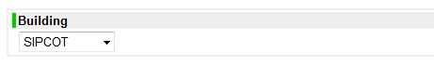

Buildings that need to be available in the drop down are detailed below

If Location is Chennai

- SIPCOT
- DLF Phase I
- DLF Phase II

If location is Bangalore

- White field –process block
- White field-ITOPS
- Whitefield-training center

If locations is Mumbai

- IKP Block A
- IKP block B

6) Floor

Drop Down field
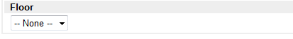

Values need to be there is

- Floor -1
- Floor -2
- Floor -3

7) Mobile number (Should auto populate):

This is a Single Line Text and read only field

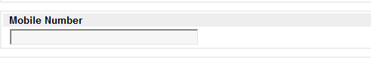

8) Email ID (Should auto populate)

This is a Single Line Text and read only field

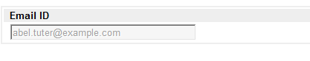

9) Software Description (Mandatory):

This is a Multi Line Text and mandatory

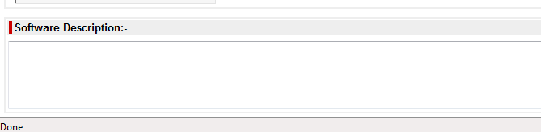

NOTE:
- Do not use glide record in client scripts (write script includes for database operations).
- For all client scripts, add glide Ajax, never use glide records.
- Write Containers to arrange variables on the form.
- Please try to add all type of variables.

Assignment:

1. Write UI Policies to make fields Mandatory and read only
2. Requestor should auto populate with current user.
3. Added Manager Field, should auto populate.
4. Added on behalf of, search only on users whose company is ACME Australia (Add Reference qualifier).

